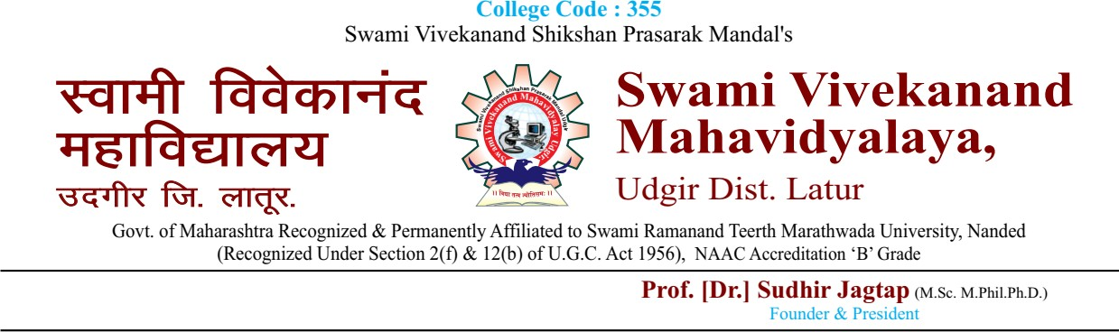

**Collaborations / Agreements / MoUs with the College/Departments**

|  |  |  |
| --- | --- | --- |
| **Sr.**  **No.** | **Name of the Institute/ University/ Department/Agency /Industry** | **Purpose** |
| 1. | SoftFeat Technologies, Umerkhed, Dist- Yavatmal. | Guest lecture on website Development. |
| 2. | Elite Software’s, Pune. | Software developer for HVAC, electrical, plumbing, and fire protection design software. |
| 3. | Excelr Solutions, Pune. | Hands on training of students on various new software’s implemented in various industry |
| 4. | Ujwal Investment Broking Pvt. Ltd,Udgir | Training the students in Investment & Broking to make them industry ready. |
| 6. | Arjit Ventures, KawalKhed, Udgir. | Seminar & Hands on training of New Industry related Software’s |
| 7. | DSJ INFOTECH INDIA PRIVATE LIMITED, Hyderabad. | Hands on training of students on Part of the Computer Systems Design and Related Services Industry |
| 8. | BitString IT pvt ltd, pune. | Training Students on Software Solution Services, Management Services, IT Resource Planning & Cyber Security Services |

|  |  |  |
| --- | --- | --- |
|  |  |  |