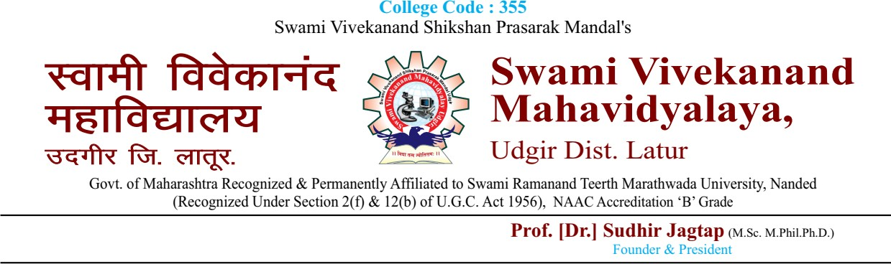

**Event Report**

**Ref/ 1QAC/Metric No:……………**

|  |  |  |  |  |
| --- | --- | --- | --- | --- |
| **Ref/1QAC/ 2022-23** | **Event Name:**  **ALUMNI MEET** | **No. Of Beneficiaries:**  **132** | **Organizing Department:**  **Internal Quality**  **Assurance Cell** | **Date and Duration:**  **15-Aug-2022** |
| **Event Objectives/ Outcomes:**   * The College organized a Parents Meet to interact with parents on various quality enhancement issues of teaching learning * Prof Dr. Kodge B. G. was the chief guest for this meet, who addressed the gathering on GITAM University, Hyderabad how practice can contribute in confidence building and success in the examinations. The parents expressed their views and the guest replied to their questions on this occasion | | | | **Chief Guest/ Resource**  **Person:**  **Dr. Kodge B. G.** |

|  |  |  |
| --- | --- | --- |
|  |  |  |

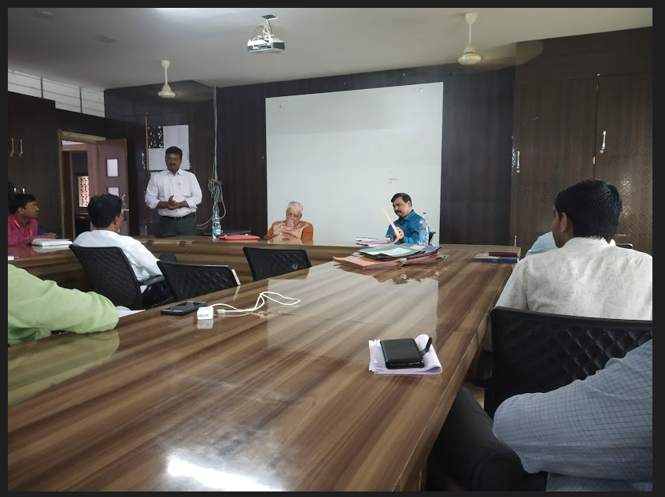

**Dr. Kodge B. G. delivering the lecture.**

|  |  |  |
| --- | --- | --- |
|  |  |  |



**Event Report**

**Ref/ 1QAC/Metric No:……………**

|  |  |  |  |  |
| --- | --- | --- | --- | --- |
| **Ref/1QAC/ 2022-23** | **Event Name:**  **FEMALE PARENTS MEET** | **No. Of Beneficiaries:**  **97** | **Organizing Department:**  **Women's Development Cell** | **Date and Duration:**  **01-May-2023** |
| **Event Objectives/ Outcomes:**   * The Women's Development Cell of the college organizes regularly the female parents meet to interact and get inputs on girl specific issues from the parents. * The College prefers to augment the campus safety and security with incorporating the feedback from the female parents. | | | | **Chief Guest/ Resource**  **Person:**  **Ms. Manoram Shashtri** |

|  |  |  |
| --- | --- | --- |
|  |  |  |

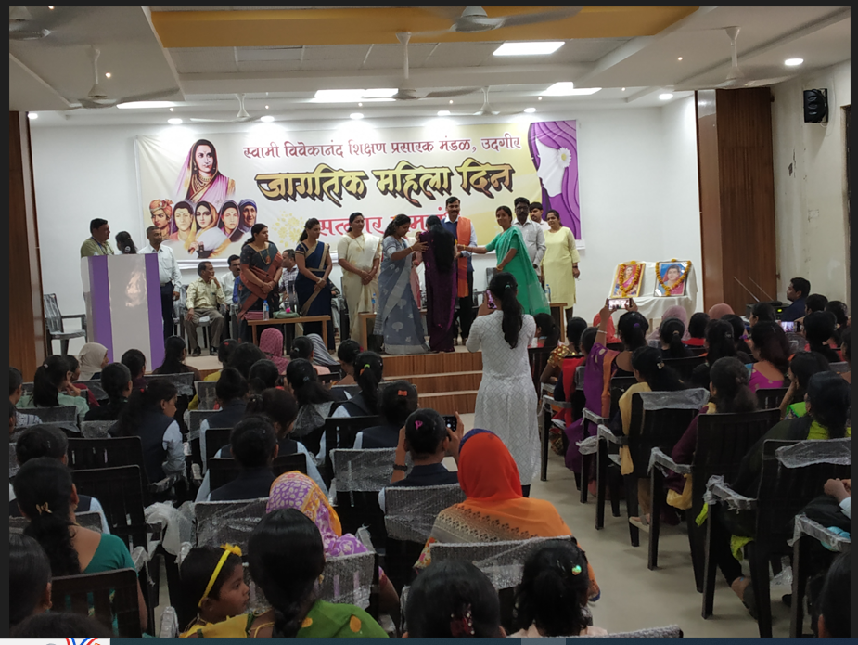

The Women's Development Cell of the college organizes regularly the female parents meet to interact and get inputs on girl specific issues from the parents.

**Chief Guest/ Resource Person: MS. Manoram Shashtri and Principal Dr. S. B. Jagtap.**

|  |  |  |
| --- | --- | --- |
|  |  |  |