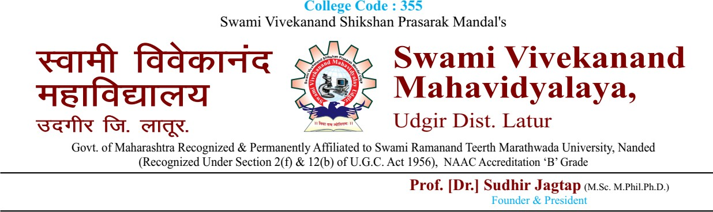

**ANNUAL ALUMINI MEET 2022-2023**

The annual Alumni Meet was organized on dated 06-FEB-2023. It started with the invocation Song by Miss V. A. Chitte. Alumni meet 2023 was inaugurated by Chief Guest Miss Shinde S. R. alumni in the year-2020-21, More than 89 alumni participated in the Alumni meet 2023.

The welcome speech was delivered by Dr. S. B. Jagtap, Principal of SVM. The dignitaries on the dais were introduced to the gathering by him and also welcomed the Heads of the department, Alumni and staffs of SVM, Udgir.

Miss Shinde S. R. delivered the Chief Guest address. **The association is of providing blood donation programe.**

Vote of thanks was delivered by Dr. Jadhav S. L., with the delicious lunch.

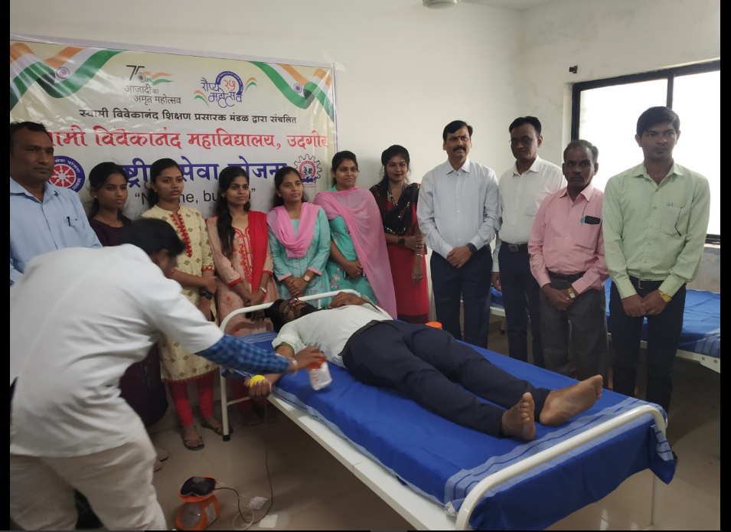

|  |  |  |
| --- | --- | --- |
|  |  |  |



Miss Shinde S. R., Inaugurate the Blood donation program in the presence of Principal Dr. S. B. Jagtap and alumni’s and also all staff member of SVM, Udgir. (Academic Year - 2022- 2023)

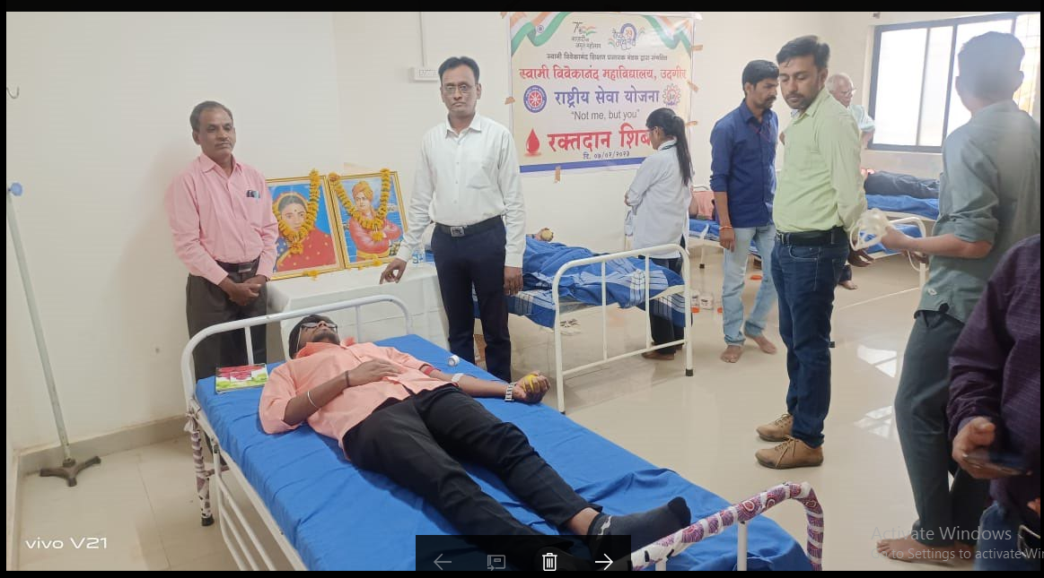

**Above photo is shown during the Blood Donation.**

**(Academic Year - 2022- 2023**)

|  |  |  |
| --- | --- | --- |
|  |  |  |



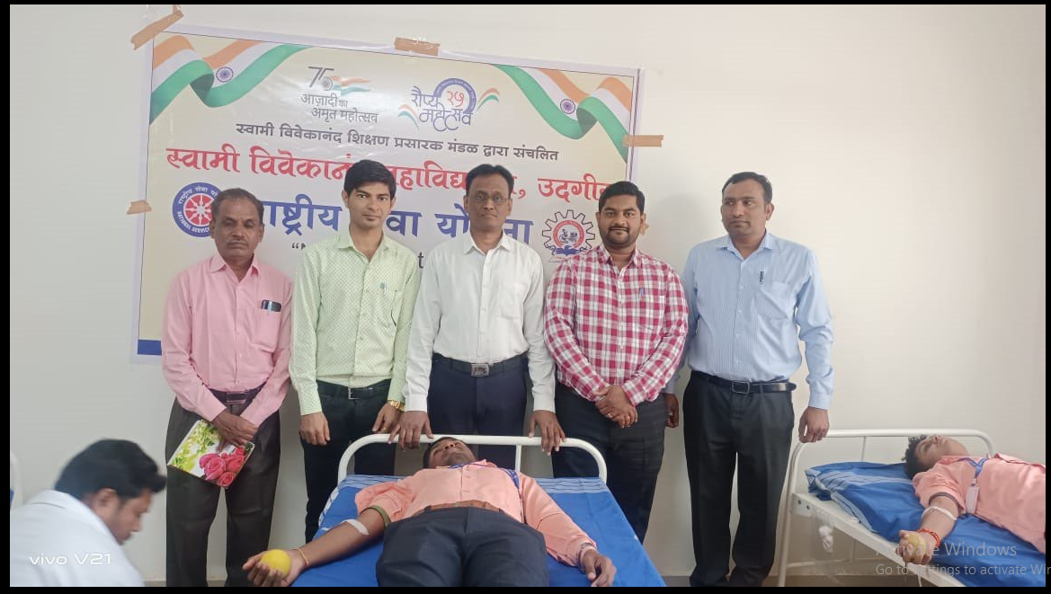

**Above photo is shown during the Blood Donation.**

**(Academic Year - 2022- 2023)**

|  |  |  |
| --- | --- | --- |
|  |  |  |



**ANNUAL ALUMINI MEET 2022-2023**

The annual Alumni Meet was organized on dated 09-Oct-2022. It started with the invocation Song by Mr. Hulsure Mahesh. Inaugurated by alumni Chief Guest Mr. T. N. Tare, Principal of Florence school of Nursing, Latur. More than 73 alumni participated in the Alumni meet 2022.

The welcome speech was delivered by Mr. R. R. Daimi, Assistant Professor Department of Computer Science. The dignitaries on the dais were introduced to the gathering by him and also welcomed the Heads of the department, Alumni and staffs of SVM, Udgir.

Mr. T. N. Tare. Delivered the Chief Guest address. The association is in practice of providing scholarships to the weaker section student’s two from each department. The scholarship amount of Rs.3500/- was handed over by Mr. T. N. Tare Principal of Florence school of Nursing, Latur.

The following students are awarded with the scholarship during alumni meet-2022-2023

|  |  |
| --- | --- |
| **Department’s** | **Full Name** |
| Computer Science | Dhawde Shoabali Sayyadali |
|  | Desai Anil Shivajirao |
| Library Science | Bijapure Mahadev Umanna |
|  | Wanlawad Pooja Ramesh |
| Life Science | Ugale Vishal Subhash |
|  | Veer Pallavi Manohar |
| Journalism and mass communication | Nirne Omkar Somnath |
|  | Singanwad Sarita Udhhavrao |

|  |  |  |
| --- | --- | --- |
|  |  |  |



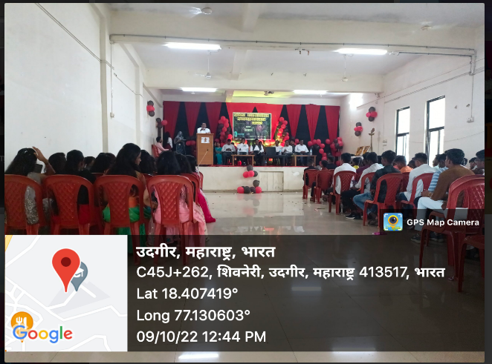

**Vote of thanks was delivered by Dr. Gond D. S., with the delicious lunch.**

|  |  |  |
| --- | --- | --- |
|  |  |  |